Education Scrutiny Committee
Meeting to be held on Tuesday, 19 July 2016

Electoral Division affected:
(All Divisions)

Proposals for Designated Children's Centres

Contact for further information:
Debbie Duffell , Head of Wellbeing, Prevention & Early Help Service,
debbie.duffell@lancashire.gov.uk

Executive Summary

This report sets out the current patterns and future proposals of service delivery in Lancashire which constitutes the 'children's centre offer', as defined in Section 2.
This report presents proposals for the future Wellbeing, Prevention & Early Help service arrangements and the scale of provision which Lancashire County Council believes is 'sufficient' in discharging its duties under the Childcare Act 2006.

Recommendation

The Committee is recommended to:
- Note the contents of the report and that the proposals are subject to the outcome of the Corporate Property Consultation
- Provide a formal response to the proposals

Background and Advice

A (Sure Start) Children’s Centre is defined in the Childcare Act 2006 as a place or a group of places:
- Which is managed by or on behalf of, or under arrangements with, the local authority with a view to securing that early childhood services in the local authority’s area are made available in an integrated way;
- Through which each of the early childhood services is made available – either by providing the services on site, or by providing advice and assistance on gaining access to those services elsewhere; and
- At which activities for young children are provided on site.

It follows from the statutory definition of a (Sure Start) Children’s Centre that children’s centres are as much about making appropriate and integrated services available, as it is about providing premises in particular geographical areas.
Early childhood services are defined as:
- Early years provision (early education and childcare);
- Social services functions of the local authority relating to young children, parents and prospective parents;
- Health services relating to young children, parents and prospective parents;
- Training and employment services to assist parents or prospective parents;
- Information and advice services for parents and prospective parents.

A children’s centre should make available universal and targeted early childhood services either by providing the services at the centre itself or by providing advice and assistance to parents and prospective parents in accessing services provided elsewhere. In order to meet the statutory definition of a children’s centre, local authorities must ensure that the children’s centre provides some activities for young children on site.

The Department views the change from a main (Designated) children’s centre to a linked site to have happened when a children’s centre ceases to fulfil the statutory definition of a children’s centre in its own right but continues to offer some early childhood services as part of another children’s centre. It is for the local authority to be satisfied that its arrangements for children's centres meet the sufficiency duty.

With respect to how many/how few activities are to be provided on site for it to remain a designated children’s centre, the centre must provide more than one activity at the centre (the legislation cites “activities” in the plural) in order to meet the statutory definition. Local authorities have a wide margin of discretion, therefore, in determining how many “activities” should be provided at the centres bearing in mind its own circumstances and local need.
Ofsted’s framework for the inspection of children’s centres defines a single centre as offering “some activities for children on at least one site” (page 22) but also highlights that, in judging a centre’s “overall effectiveness” judgment Ofsted will:
“Consider whether the centre is meeting its legal requirements in making sufficient early childhood services available to parents and prospective parents in its reach area/locality, including the activities it offers on site. Inspectors will also consider the difference the centre makes to the young children and families in the local area it serves.”
It should be noted that the Ofsted framework for the inspection of children's centres is currently paused and subject to a full review.
The children's centre offer in Lancashire in the future will be delivered as part of an integrated Wellbeing, Prevention and Early Help Service (WPEHS), offering a range of services and support to children, young people and their families across the 0-19yrs+ age range.
Population/residency figures indicate that with respect to the current provision of children centres in Lancashire, 98% of the most deprived 0-4yr olds and 80% of least deprived 0-4yr olds are within a reasonable access distance of a children's centre provision.
 | Age population band within Census Output Areas | Census Output Areas within 1.5 miles of the current 127 existing WPEH centres including children centres (30 minutes walking/pram pushing distance)
 | In most deprived deciles 1 to 5¹
 | Total | Within radius | %
Age 0 to 4 | 39,967 | 39,279 | 98.28%
Age 5 to 11 | 47,138 | 45,996 | 97.58%
Age 12 to 18 | 50,933 | 49,592 | 97.37%
 | In least deprived deciles 6 to 11²
 | Total | Within radius | %
Age 0 to 4 | 28,624 | 22,967 | 80.24%
Age 5 to 11 | 42,557 | 33,232 | 78.09%
Age 12 to 18 | 50,224 | 39,015 | 77.68%

Proposed changes to the location, distribution, scope and scale of children's centre provision in the future have been considered with respect to the impact on access for children and families in Lancashire.
Analysis of the Census and Lower Super Output Area figures and the proposed future delivery model indicates that there will be some reduction in access, where the percentage population of most deprived 0-4yrs within radius may reduce to from 98.28% to 94% (a 4% drop in access).
The impact on the least deprived 0-4yrs indicates a drop from 80.24% to 63% (a 17% drop in access). This is commensurate with the aspiration that future services will be targeted primarily to those in most need.
 | Census output area figures (2011) |  |  |  | Lower Super Output Area Midyear estimate figures (2014)
 | Future proposed WPEHS Delivery sites (Neighbourhood Centres) |  |  |  | Future proposed WPEHS Delivery Sites (Neighbourhood Centres)
 | Within 1.5 miles |  |  |  | Within 1.5 miles
 | Total | Number | % |  | Total | Number | %
Age 0 to 4 | 68,591 | 55,597 | 81.06% |  | 69,066 | 56,177 | 81.34%
Age 5 to 11 | 89,695 | 69,694 | 77.70% |  | 94,610 | 73,892 | 78.10%
Age 12 to 18 | 101,157 | 77,229 | 76.35% |  | 95,704 | 73,318 | 76.61%
SEND 19 to 24 | 2,838 | 2,415 | 85.10%
Most deprived ¹ |  | Within 1.5 miles |  |  |  | Within 1.5 miles
 | Total | Number |  | % | Total | Number | %
Age 0 to 4 | 39,967 | 37,624 |  | 94.14% | 40,959 | 38,391 | 93.73%
Age 5 to 11 | 47,138 | 43,926 |  | 93.19% | 51,019 | 47,456 | 93.02%
Age 12 to 18 | 50,933 | 47,292 |  | 92.85% | 48,337 | 44,899 | 92.89%
Least deprived ² |  | Within 1.5 miles |  |  |  | Within 1.5 miles
 | Total | Number |  | % | Total | Number | %
Age 0 to 4 | 28,624 | 17,973 |  | 62.79% | 28,107 | 17,786 | 63.28%
Age 5 to 11 | 42,557 | 25,768 |  | 60.55% | 43,591 | 26,436 | 60.65%
Age 12 to 18 | 50,224 | 29,937 |  | 59.61% | 47,367 | 28,419 | 60.00%
* Actual postcodes for SEND service users aged 19 to 24 - date unknown
1 Output areas and LSOAs in the most deprived deciles in IMD 2015
2 Output areas and LSOAs in the least deprived deciles in IMD 2015

The maps and tables which follow, outline the changes that are proposed to the locations through which services will be made available and demonstrate how these geographically map across the neighbourhoods in local areas. They also indicate the scale of provision proposed at each location and the impact (where relevant) that any proposed changes will have on the designation of individual centres.
The future governance arrangements for the new delivery model (WPEHS), through which the children's centre core offer will be provided, will adopt a group delivery model arrangement in which children's centre services will be clustered at a District level.

Each cluster group will include a number of both main centres (Designated) and linked sites as appropriate. These will be indicative of the scale of provision delivered at each site, however, all will include delivery of early childhood services within a wider 0-19+yrs service.

The scale of provision will be determined by a centre being either designated as a main centre or as a linked centre with the appropriate level of resources deployed in each setting.
Further details of the level of offer to be delivered at each centre is outlined in the tables in Section 4.

A summary of how the proposed changes impact on the designation status of Lancashire's current children's centres is summarised in the following table;
District | Designation status – Lancashire Children's Centres
District | Original total number of main centres | Original total number of linked centres | District Total | Future total number of main centres | Future total number of linked centres | Future District Total | Variance
Lancaster | 8 | 2 | 10 | 6 | 0 | 6 | -4
Wyre | 5 | 4 | 9 | 5 | 0 | 5 | -4
Fylde | 3 | 3 | 6 | 3 | 0 | 3 | -3
Preston | 7 | 1 | 8 | 6 | 1 | 7 | -1
South Ribble | 4 | 2 | 6 | 3 | 0 | 3 | -3
Chorley | 5 | 3 | 8 | 3 | 0 | 3 | -5
West Lancashire | 6 | 1 | 7 | 5 | 1 | 6 | -1
Hyndburn | 6 | 1 | 7 | 2 | 3 | 5 | -2
Ribble Valley | 2 | 1 | 3 | 2 | 0 | 2 | -1
Rossendale | 5 | 0 | 5 | 3 | 0 | 3 | -2
Burnley | 6 | 0 | 6 | 5 | 1 | 6 | 0
Pendle | 5 | 2 | 7 | 4 | 1 | 5 | -2

The following map provides an overview of all existing and proposed locations for service delivery in Lancashire which will incorporate the children's centre core offer services.
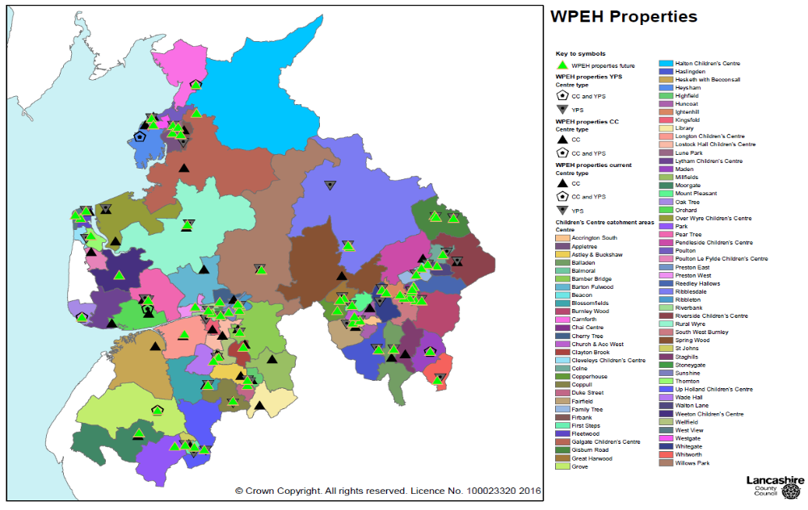

Area mapping and centre by centre breakdown of proposals

4.1 Lancashire North
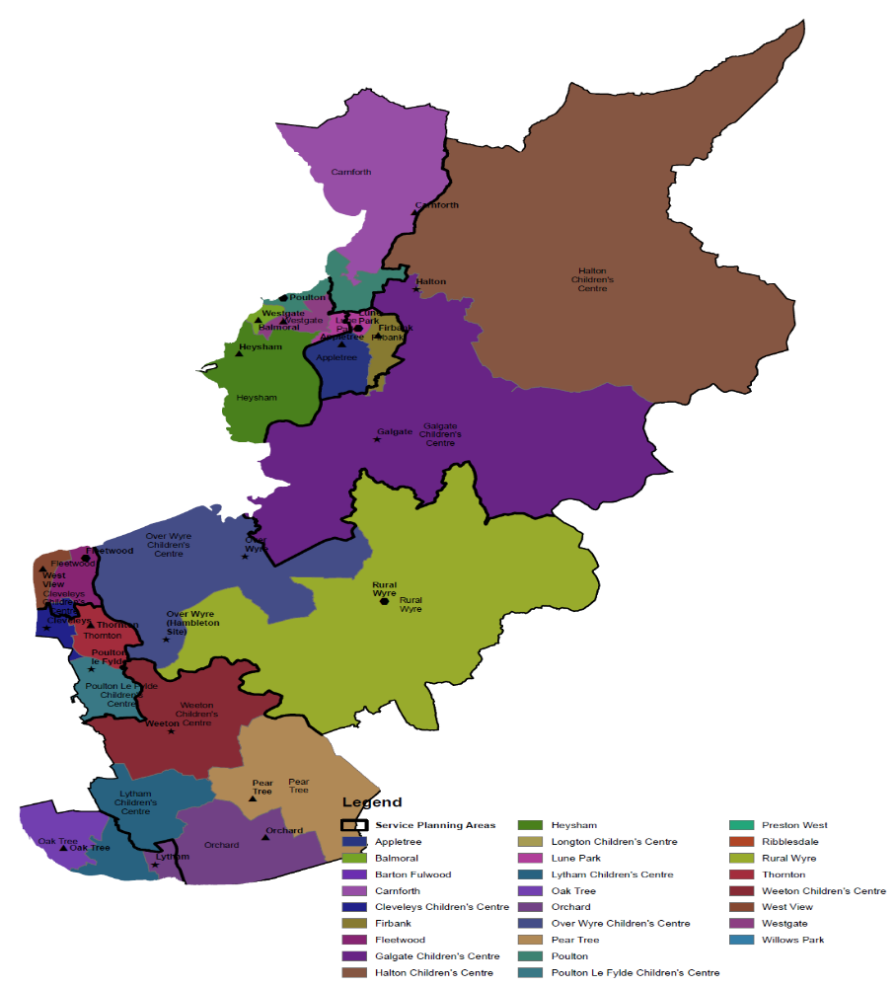
North Lancashire Children Centres

MAP KEY;
Black borders = service planning areas within districts.
Coloured Blocks = Individual children centre reach
Lancaster district

Current Designated Main Centres | Dept. for Education  Edubase Reference | Future Offer Level | Early childhood services to be provided in future |  |  |  |  |  | Proposal | Designation Outcome
Current Designated Main Centres | Dept. for Education  Edubase Reference | Future Offer Level | Early years provision (education/ childcare) |  | Social services functions | Health services | Training and employment services | Information and advice | Proposal | Designation Outcome
Current Designated Main Centres | Dept. for Education  Edubase Reference | Future Offer Level | Provided on site | Advice & assistance to access elsewhere | Relating to young children, parents and prospective parents |  |  |  | Proposal | Designation Outcome
Poulton Children's Centre in Morecambe | 22410 | Whole  Enhanced |  | √ | √ | √ | √ | √ | Withdraw from existing site. Transfer to operate future service delivery from an alternative neighbourhood centre; Morecambe Library | Transfer  Designated main children's centre status to Morecambe library.
Balmoral Children's Centre in Morecambe | 20176 | None | n/a | n/a | n/a | n/a | n/a | n/a | Close centre | Closure.  Nearest point of access – Westgate children's centre.
Heysham Children's Centre in Heysham | 21470 | None | n/a | n/a | n/a | n/a | n/a | n/a | Close centre | Closure  Nearest point of success – Westgate Children's centre, Morecambe
Westgate Children's Centre | 23540 | Whole  Core | √ |  | √ | √ | √ | √ | Delivery of a whole core offer incorporating children centre core offer with some outreach facility within Heysham Library to meet community need. | No Change  Continue to be designated as a main centre.
Lune Park Children's Centre in Lancaster | 23050 | Whole  Core | √ |  | √ | √ | √ | √ | Delivery of a whole core offer incorporating children's centre core offer. | No Change  Continue to be designated as a main centre.
Appletree Children's Centre in Lancaster | 20101 | Split  Core | √ |  | √ | √ | √ | √ | Delivery of a split core offer incorporating children's centre core offer | No Change  Continue to be designated as a main centre.
Firbank Children's Centre in Lancaster | 21172 | None | n/a | n/a | n/a | n/a | n/a | n/a | Close centre | Closure  Nearest point of access – Appletree Children's Centre, Lancaster
Carnforth Hub Children's Centre and Young People's Centre in Carnforth | 23164 | Whole  Core |  | √. | √ | √ | √ | √ | Deliver of a whole core offer incorporating children's centre core offer. | No change  Continue to be designated as a main centre.

Current Linked Sites (satellite provision)
Halton Children's Centre at Halton Library | 21351 | Split  Core |  | √ | √ | √ | √ | √ | Delivery of a split core offer incorporating children's centre core offer. | Designated main children's centre status.
Galgate Children's Centre in Galgate | 21232 | None | n/a | n/a | n/a | n/a | n/a | n/a | Close centre | Closure  Nearest point of access to services – Appletree Children's Centre.

Wyre district

Current Designated Main Centres | Dept. for Education  Edubase Reference | Future Offer Level | Early childhood services to be provided in future |  |  |  |  |  | Proposal | Designation Outcome
Current Designated Main Centres | Dept. for Education  Edubase Reference | Future Offer Level | Early years provision (education/ childcare) |  | Social services functions | Health services | Training and employment services | Information and advice | Proposal | Designation Outcome
Current Designated Main Centres | Dept. for Education  Edubase Reference | Future Offer Level | Provided on site | Advice & assistance to access elsewhere | Relating to young children, parents and prospective parents |  |  |  | Proposal | Designation Outcome
West View Children's Centre in Fleetwood | 23526 | Whole  Core | √ |  | √ | √ | √ | √ | Delivery of a whole core offer incorporating children centre core offer | No change  Continue to be designated as a main centre.
Flakefleet Children's Centre at Library | 23044 | Whole  Core |  | √ | √ | √ | √ | √ | Delivery of a whole core offer incorporating children's centre core offer | Designated as a main children's centre.
Fleetwood Children's Centre, Kemp Street in Fleetwood | 23044 | Whole  Enhanced |  | √ | √ | √ | √ | √ | Withdraw from existing site. Transfer to operate future service from an alternative neighbourhood centre; The Zone in Fleetwood. | Transfer  Designated main children's centre status to the Zone, Fleetwood.
Rural Wyre Children's Centre in Garstang | 22589 | Whole  Core |  | √ | √ | √ | √ | √ | Withdraw from existing site. Transfer to operate future service delivery from an alternative neighbourhood centre; Garstang Library | Transfer  Designated main children's centre status to Garstang Library.
Thornton Children's Centre in Thornton | 23297 | Whole  Core |  | √ | √ | √ | √ | √ | Delivery of a whole core offer incorporating children's centre core offer. | No Change  Continue to be designated as a main children's centre.

Current Linked Sites (satellite provision)
Current Designated Main Centres | Dept. for Education  Edubase Reference | Future Offer Level |  | Early childhood services to be provided in future |  |  |  |  |  |  | Proposal |  | Designation Outcome
Hambleton Children's Centre (Over Wyre) Hambleton satellite | 22287 | None | n/a |  | n/a | n/a | n/a | n/a | n/a | Close Centre |  | Closure  Nearest point of access to services – Thornton Children's Centre in Thornton
Over Wyre Children's centre (Preesall satellite) in Preesall | 22287 | None | n/a |  | n/a | n/a | n/a | n/a | n/a | Close Centre |  | Closure  Nearest point of access to services – Thornton Children's Centre in Thornton
Poulton le Fylde Children's Centre | 22411 | None | n/a |  | n/a | n/a | n/a | n/a | n/a | Close Centre |  | Closure  Nearest point of access to services – Thornton Children's Centre in Thornton.
Cleveleys children's centre in Cleveley's Library | 20758 | None | n/a |  | n/a | n/a | n/a | n/a | n/a | Close Centre |  | Closure  Nearest point of access to services – Thornton Children's Centre in Thornton.

Fylde district
Current Designated Main Centres | Dept. for Education  Edubase Reference | Future Offer Level |  | Early childhood services to be provided in future |  |  |  |  |  |  |  |  |  |  |  | Proposal |  | Designation Outcome
Current Designated Main Centres | Dept. for Education  Edubase Reference |  |  | Early years provision (education/ childcare) |  |  |  | Social services functions |  | Health services |  | Training and employment services |  | Information and advice
Current Designated Main Centres | Dept. for Education  Edubase Reference |  |  | Provided on site |  | Advice & assistance to access elsewhere |  | Relating to young children, parents and prospective parents
Oak Tree Children's Centre in St Annes | 22218 | Whole  Core |  |  |  | √ |  | √ |  | √ |  | √ |  | √ |  | Delivery of a whole core offer incorporating children's centre core offer |  | No Change  Continue to be designated as a main children's centre.
Pear Tree Children's Centre in Kirkham | 22340 | Whole  Enhanced |  |  |  | √ |  | √ |  | √ |  | √ |  | √ |  | Withdraw from existing site. Transfer to operate future service delivery from an alternative neighbourhood centre; The Zone, Kirkham |  | Transfer  Designated main children's centre status to the Zone, Kirkham.
The Orchard Children's Centre in Freckleton | 23227 | None |  | n/a |  | n/a |  | n/a |  | n/a |  | n/a |  | n/a |  | Close Centre |  | Closure  Nearest point of access to services – The Zone, Kirkham
Current Linked Sites (satellite provision)
Lytham Children's Centre in Lytham | 21888 | None | n/a |  | n/a |  | n/a |  | n/a |  | n/a |  | n/a |  | Close centre |  | Closure  Nearest point of access to services – Oak tree children's centre in St Annes.
Weeton Children's Centre at Weeton Barracks | 23468 | Split  Enhanced |  |  | √ |  | √ |  | √ |  | √ |  | √ |  | Delivery of a split enhanced offer with The Zone in Kirkham incorporating children's centre core offer |  | Designated as a main children's centre.
Barton St. Lawrence Children's Centre in Barton |  | None | n/a |  | n/a |  | n/a |  | n/a |  | n/a |  | n/a |  | Close Centre |  | Closure  Nearest point of access to services – Cherry Tree children's centre, Preston.

4.2 Lancashire South
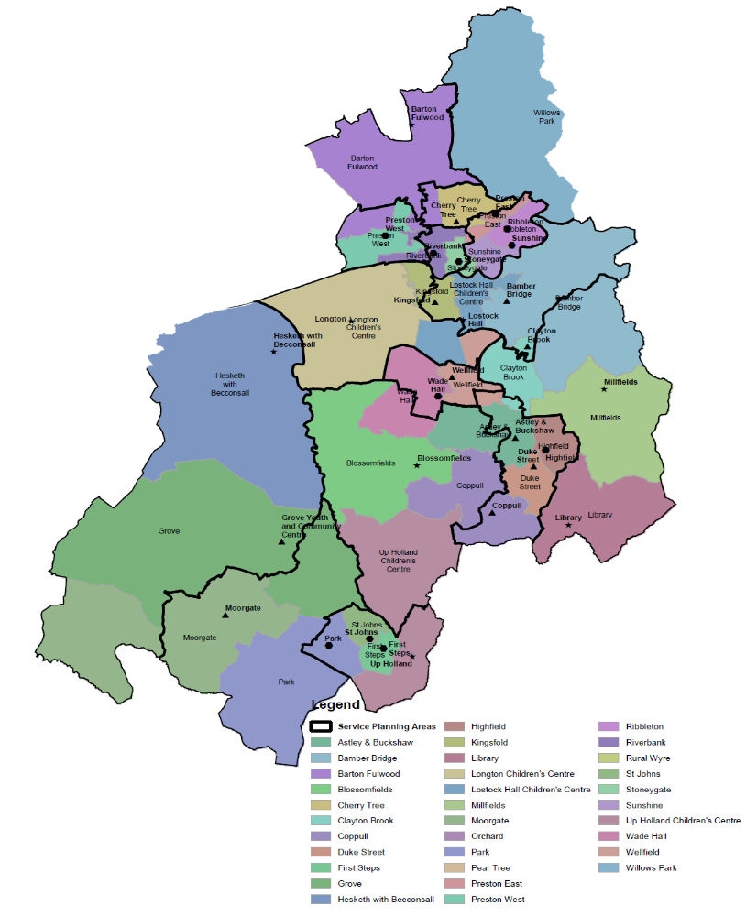
South Lancashire Children Centres

MAP KEY;
Black borders = service planning areas within districts.
Coloured Blocks = Individual children centre reach
Preston district
Current Designated Main Centres | Dept. for Education  Edubase Reference | Future Offer Level | Early childhood services to be provided in future |  |  |  |  |  | Proposal | Designation Outcome
Current Designated Main Centres | Dept. for Education  Edubase Reference | Future Offer Level | Early years provision (education/ childcare) |  | Social services functions | Health services | Training and employment services | Information and advice | Proposal | Designation Outcome
Current Designated Main Centres | Dept. for Education  Edubase Reference | Future Offer Level | Provided on site | Advice & assistance to access elsewhere | Relating to young children, parents and prospective parents |  |  |  | Proposal | Designation Outcome
Preston East Children's Centre in Preston | 23054 | None | n/a | n/a | n/a | n/a | n/a | n/a | Close provision and deliver from Ribbleton children's centres | Closure  Nearest point of access to services Ribbleton children's centre
Preston West Children's Centre in Preston | 23055 | Whole  Core | √ |  | √ | √ | √ | √ | Delivery of a whole core offer incorporating children centre core offer | No change  Continue to be designated as a main centre.
Ribbleton Children's Centre in Preston | 23058 | Whole  Core | √ |  | √ | √ | √ | √ | Delivery of a whole core offer incorporating children's centre offer | No change  Continue to be designated as a main centre.
Sunshine Children's Centre in Preston | 23009 | Split  Enhanced |  | √ | √ | √ | √ | √ | Delivery of a split enhanced offer incorporating children's centred offer using New Hall lane drop in for some outreach provision | No change  Continue to be designated as a main centre and will be the lead centre for the Preston group model.
Riverbank Children's Centre in Preston | 23059 | Whole  Core | √ |  | √ | √ | √ | √ | Delivery of a whole core offer incorporating children centre core offer | No change  Continue to be designated as a main centre.
Stoneygate Children's Centre in Preston | 22950 | Whole  Core | √ |  | √ | √ | √ | √ | Delivery of a whole core offer incorporating children centre core offer | No change  Continue to be designated as a main centre.
Cherry Tree Children's Centre in Preston | 20667 | Whole  Core |  | √ | √ | √ | √ | √ | Delivery of a whole core offer incorporating children centre core offer | No change  Continue to be designated as a main centre.

Current Linked Sites (satellite provision)
New Hall lane drop-in, in Preston | 23009 | Split  Enhanced |  | √ | √ |  |  | √ | Delivery of some outreach to offer outreach provision to Sunshine children's centre. | Delivery of some outreach  No change

South Ribble district

Current Designated Main Centres | Dept. for Education  Edubase Reference | Future Offer Level | Early childhood services to be provided in future |  |  |  |  |  | Proposal | Designation Outcome
Current Designated Main Centres | Dept. for Education  Edubase Reference | Future Offer Level | Early years provision (education/ childcare) |  | Social services functions | Health services | Training and employment services | Information and advice | Proposal | Designation Outcome
Current Designated Main Centres | Dept. for Education  Edubase Reference | Future Offer Level | Provided on site | Advice & assistance to access elsewhere | Relating to young children, parents and prospective parents |  |  |  | Proposal | Designation Outcome
Wade Hall | 23434 | Split  Core | √ |  | √ | √ | √ | √ | Delivery of a split Core offer incorporating children centre core offer | No change to Designation  Continue as link centre
Wellfield | 23471 | Split  Core |  | √ | √ | √ | √ | √ | Withdraw from existing site. Transfer to operate future service from an alternative neighbourhood centres; The Zone (main centre), Wade Hall CC site and Leyland Library site.  The Zone Leyland will be the main designated centre with a whole enhanced offer, and lead site for South Ribble group model. | Transfer  Designated main children's centre status to The Zone, Leyland
Bamber Bridge | 20178 | Whole  Core |  | √ | √ | √ | √ | √ | Withdraw from existing site. Transfer to operate future service from an alternative neighbourhood centre; Walton le Dale YPC site | Transfer  Designated main children's centre status to Walton le Dale YPC
Kingsfold | 21684 | Whole  Core |  | √ | √ | √ | √ | √ | Withdraw from existing site. Transfer to operate future service from an alternative neighbourhood centre; Walton le Dale YPC site or Riverbank CC, Preston | Transfer  Designated main children's centre status to Walton le Dale YPC

Current Linked Sites (satellite provision)
Lostock Hall | 21862 | None | n/a | n/a | n/a | n/a | n/a | n/a | Close satellite provision | Closure  Nearest point of access main site at;  Walton le Dale YPC site
Longton | 21856 | None | n/a | n/a | n/a | n/a | n/a | n/a | Close satellite provision | Closure  Nearest point of access link site; Longton Library

Chorley district

Current Designated Main Centres |  | Dept. for Education  Edubase Reference |  | Future Offer Level |  | Early childhood services to be provided in future |  |  |  |  |  |  |  |  |  |  | Proposal |  | Designation Outcome
 |  |  |  |  |  | Early years provision (education/ childcare) |  |  |  | Social services functions |  | Health services |  | Training and employment services |  | Information and advice
 |  |  |  |  |  | Provided on site |  | Advice & assistance to access elsewhere |  | Relating to young children, parents and prospective parents
Clayton Brook |  |  |  | Whole  Core |  |  |  | √ |  | √ |  | √ |  | √ |  | √ | Withdraw from existing site. Transfer to operate future service from an alternative neighbourhood centre;  Clayton Green Library Site |  | Transfer  Designated main children's centre status to Clayton Green Library site
Coppull |  | 20815 |  | Split  Core |  |  |  | √ |  | √ |  | √ |  | √ |  | √ | Withdraw from existing site. Transfer to operate future service from an alternative neighbourhood centre; Coppull Library site.  Union Street Chorley site will be the main designated centre with a whole enhanced offer, and lead site for Chorley group model. |  | Transfer  Designated main children's centre status to Union St site
Highfield |  | 21481 |  | Split  Core |  |  |  | √ |  | √ |  | √ |  | √ |  | √ | Withdraw from existing site. Transfer to operate future service from an alternative neighbourhood centre; Duke St Children's Centre site |  | Transfer  Designated main children's centre status to Union St site
Astley and Buckshaw |  | 20134 |  | Whole  Enhanced |  |  |  | √ |  | √ |  | √ |  | √ |  | √ | Withdraw from existing site. Transfer to operate future service from an alternative neighbourhood centre; Union St site or Duke St CC |  | Transfer  Designated main children's centre status to Union St site
Duke St |  | 20988 |  | Split  Core |  | √ |  |  |  | √ |  | √ |  | √ |  | √ | Delivery of a split Core offer incorporating children centre core offer |  | No change to Designation  Continue as link centre
Current Linked Sites (satellite provision)
Library CC, Adlington | 22826 |  | None |  | n/a |  | n/a |  | n/a |  | n/a |  | n/a |  | n/a |  |  | Close satellite provision |  | Closure  Nearest point of access main site at;  Duke St CC
Blossomfields | 20344 |  | None |  | n/a |  | n/a |  | n/a |  | n/a |  | n/a |  | n/a |  |  | Close satellite provision |  | Closure  Nearest point of access main site at;  Eccleston Library site
Millfields | 22016 |  | None |  | n/a |  | n/a |  | n/a |  | n/a |  | n/a |  | n/a |  |  | Close satellite provision |  | Closure  Nearest point of access main site at;  Clayton Green Library site or Union St site

West Lancashire district

Current Designated Main Centres | Dept. for Education  Edubase Reference | Future Offer Level | Early childhood services to be provided in future |  |  |  |  |  | Proposal | Designation Outcome
Current Designated Main Centres | Dept. for Education  Edubase Reference | Future Offer Level | Early years provision (education/ childcare) |  | Social services functions | Health services | Training and employment services | Information and advice | Proposal | Designation Outcome
Current Designated Main Centres | Dept. for Education  Edubase Reference | Future Offer Level | Provided on site | Advice & assistance to access elsewhere | Relating to young children, parents and prospective parents |  |  |  | Proposal | Designation Outcome
Park | 22309 | Split  Core | √ |  | √ | √ | √ | √ | Delivery of a split Core offer incorporating children centre core offer | No change  Continue as link centre
First Steps | 21175 | Split  Enhanced | √ |  | √ | √ | √ | √ | Delivery of a split Enhanced offer incorporating children centre core offer | No change  Continue to be designated a main centre and lead site for West Lancashire group model
St Johns CC | 22855 | Split  Enhanced | √ | √ | √ | √ | √ | √ | Withdraw from existing site. Transfer to operate future service from an alternative neighbourhood centre; The Zone site Skelmersdale or First Steps CC site | Transfer  Designated main children's centre status to The Zone, Skelmersdale
Grove | 23194 | Whole  Core |  | √ | √ | √ | √ | √ | Delivery of a whole Core offer incorporating children centre core offer | No Change
Hesketh with Becconsall Children's Centre | 21462 | Whole  Core |  | √ | √ | √ | √ | √ | Withdraw from existing site. Transfer to operate future service from an alternative neighbourhood centre;  The Grove or Longton Library | Transfer  Designated main children's centre status to The Grove
Moorgate Children Centre | 22040 | Whole  Core |  | √ | √ | √ | √ | √ | Withdraw from existing site. Transfer to operate future service from an alternative neighbourhood centre;  Ormskirk Library site | Transfer  Designated main children's centre status to Ormskirk Library

Current Linked Sites (satellite provision)
Upholland Children Centre | 23381 | Split  Core |  | √ | √ | √ | √ | √ | Delivery of a split Core offer incorporating children centre core offer | No change  Continue as link centre

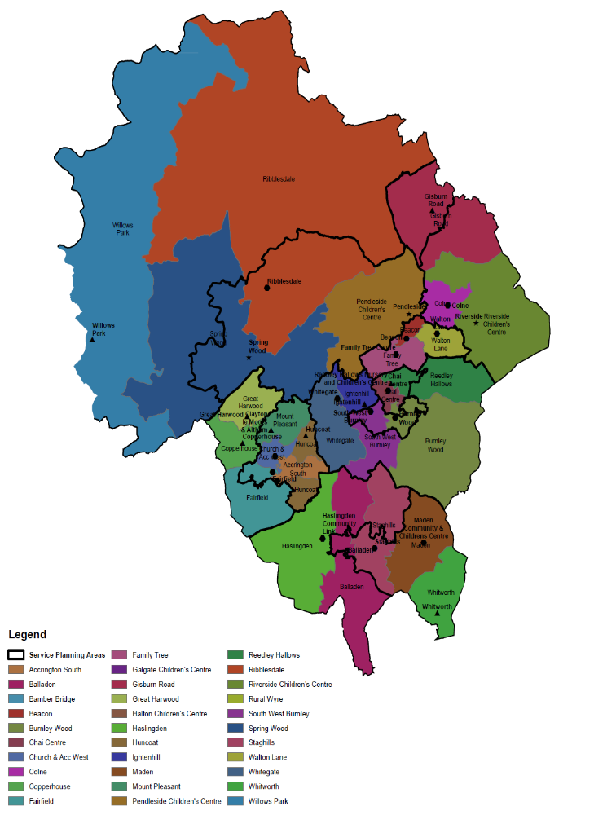
East Lancashire Children Centres

MAP KEY;
Black borders = service planning areas within districts.
Coloured Blocks = Individual children centre reach
Hyndburn district
Current Designated Main Centres | Dept. for Education  Edubase Reference | Future Offer Level |  | Early childhood services to be provided in future |  |  |  |  |  |  |  |  |  |  |  | Proposal |  | Designation Outcome
Current Designated Main Centres | Dept. for Education  Edubase Reference |  |  | Early years provision (education/ childcare) |  |  |  | Social services functions |  | Health services |  | Training and employment services |  | Information and advice
Current Designated Main Centres | Dept. for Education  Edubase Reference |  |  | Provided on site |  | Advice & assistance to access elsewhere |  | Relating to young children, parents and prospective parents
Sure Start Hyndburn, Accrington South (The Beeches) Children Centre | 23046 | n/a |  | n/a |  | n/a |  | n/a |  | n/a |  | n/a |  | n/a |  | Close provision |  | Closure  Nearest point of access to services – Fairfield CC
Sure Start Hyndburn, Church and Accrington West (The Park) Children Centre | 23047 | Split  Enhanced |  | √ |  |  |  | √ |  | √ |  | √ |  | √ |  | Delivery of a split enhanced offer incorporating children centre core offer |  | No change  Continue to be designated a main centre and lead site for Hyndburn group model
Fairfield Children Centre | 21129 | Split  Core |  | √ |  |  |  | √ |  | √ |  | √ |  | √ |  | Delivery of a split core offer incorporating children centre core offer |  | Transfer  Re-designate as linked children's centre – change of status. Link to The Park CC in Accrington
Great Harwood Children Centre | 21297 | Split  Core |  |  |  | √ |  | √ |  | √ |  | √ |  | √ |  | Delivery of a split core offer incorporating children centre core offer |  | Transfer  Re-designate as linked children's centre – change of status. Link to Copperhouse CC in Rishton
Copperhouse Children Centre, Rishton | 20813 | Whole  Core |  |  |  | √ |  | √ |  | √ |  | √ |  | √ |  | Delivery of a whole core offer incorporating children centre core offer |  | No change  Continue to be designated a main centre
Clayton and Altham Children Centre | 22064 | Split Core |  |  |  | √ |  | √ |  | √ |  | √ |  | √ |  | Delivery of a split core offer incorporating children centre core offer |  | Transfer  Re-designate as linked children's centre – change of status. Link to Copperhouse CC in Rishton
Current Linked Sites (satellite provision)
Huncoat Children Centre | 21581 | n/a | n/a |  | n/a |  | n/a |  | n/a |  | n/a |  | n/a |  | Close provision |  | ClosureNearest point of access Park CC

Ribble Valley district

Current Designated Main Centres | Dept. for Education  Edubase Reference | Future Offer Level | Early childhood services to be provided in future |  |  |  |  |  | Proposal | Designation Outcome
Current Designated Main Centres | Dept. for Education  Edubase Reference | Future Offer Level | Early years provision (education/ childcare) |  | Social services functions | Health services | Training and employment services | Information and advice | Proposal | Designation Outcome
Current Designated Main Centres | Dept. for Education  Edubase Reference | Future Offer Level | Provided on site | Advice & assistance to access elsewhere | Relating to young children, parents and prospective parents |  |  |  | Proposal | Designation Outcome
Ribblesdale Children's Centre in Clitheroe | 22499 | Split  Enhanced | √ |  | √ | √ | √ | √ | Delivery of a split enhanced offer incorporating children centre core offer | No change  Continue to be designated a main centre and lead site for Ribble Valley group model
Willows Park Children's Centre in Longridge | 23602 | Whole  Core |  | √ | √ | √ | √ | √ | Withdraw from existing site. Transfer to operate future service from an alternative neighbourhood centre; Longridge Library | Transfer  Designated main children's centre status to Longridge Library site

Current Linked Sites (satellite provision)
Spring Wood Children's Centre at Whalley Library | 22818 | None | n/a | n/a | n/a | n/a | n/a | n/a | Close satellite provision | Closure  Nearest point of access to services – main site at Ribblesdale, Clitheroe

Rossendale district
Current Designated Main Centres | Dept. for Education  Edubase Reference | Future Offer Level | Early childhood services to be provided in future |  |  |  |  |  | Proposal | Designation Outcome
Current Designated Main Centres | Dept. for Education  Edubase Reference | Future Offer Level | Early years provision (education/ childcare) |  | Social services functions | Health services | Training and employment services | Information and advice | Proposal
Current Designated Main Centres | Dept. for Education  Edubase Reference | Future Offer Level | Provided on site | Advice & assistance to access elsewhere | Relating to young children, parents and prospective parents |  |  |  | Proposal
Balladen  Children Centre | 20175 | None | n/a | n/a | n/a | n/a | n/a | n/a | Close children centre provision only at the site and transfer designation to new site.  School provision will continue | Transfer  Designated main children's centre status to The Zone in Rawtenstall
Haslingden Community Link Children Centre | 21397 | Whole  Core | √ |  | √ | √ | √ | √ | Delivery of a whole core offer incorporating children centre core offer | No change  Continue to be designated a main centre
Staghills Children Centre | 22901 | None | n/a | n/a | n/a | n/a | n/a | n/a | Close children centre provision only.  Nursery provision will continue | Closure  Nearest point of access to services – newly designated main site at The Zone, Rawtenstall
The Maden Children Centre, Bacup | 23215 | Split Enhanced | √ |  | √ | √ | √ | √ | Delivery of a split enhanced offer incorporating children centre core offer | No change  Continue to be designated a main centre and lead site for Rossendale group model
Whitworth Children Centre | 23585 | Split Enhanced |  | √ | √ | √ | √ | √ | Delivery of a split enhanced offer incorporating children centre core offer | Transfer  Reassign status to that of a linked centre as a result of splitting enhanced model with Maden Centre
Current Linked Sites (satellite provision) n/a in Rossendale District
Burnley district
Current Designated Main Centres | Dept. for Education  Edubase Reference | Future Offer Level | Early childhood services to be provided in future |  |  |  |  |  | Proposal | Designation Outcome
Current Designated Main Centres | Dept. for Education  Edubase Reference | Future Offer Level | Early years provision (education/ childcare) |  | Social services functions | Health services | Training and employment services | Information and advice | Proposal | Designation Outcome
Current Designated Main Centres | Dept. for Education  Edubase Reference | Future Offer Level | Provided on site | Advice & assistance to access elsewhere | Relating to young children, parents and prospective parents |  |  |  | Proposal | Designation Outcome
Burnley Wood Children Centre | 20511 | Split  Enhanced |  | √ | √ | √ | √ | √ | Delivery of a split enhanced offer incorporating children centre core offer | No change  Continue to be designated a main centre and lead site for Burnley group model
South West Burnley Children Centre | 23064 | Whole  Core | √ |  | √ | √ | √ | √ | Delivery of a whole core offer incorporating children centre core offer | No change  Continue to be designated a main centre
The Chai Children Centre | 23167 | Whole  Core | √ |  | √ | √ | √ | √ | Delivery of a whole core offer incorporating children centre core offer | No change  Continue to be designated a main centre
Reedley Hallows Children Centre | 22491 | Whole  Core | √ |  | √ | √ | √ | √ | Delivery of a whole core offer incorporating children centre core offer | No change  Continue to be designated a main centre
Ightenhill Children Centre | 21601 | Split  Core |  | √ | √ | √ | √ | √ | Delivery of a split core offer incorporating children centre core offer | Transfer  Change designation to a linked site. Link to Whitegate centre
Whitegate Children Centre, Padiham | 22300 | Whole  Core | √ |  | √ | √ | √ | √ | Delivery of a whole core offer incorporating children centre core offer | No change  Continue to be designated a main centre
Current Linked Sites (satellite provision) N/A in Burnley District

Pendle district
Current Designated Main Centres | Dept. for Education  Edubase Reference | Future Offer Level |  | Early childhood services to be provided in future |  |  |  |  |  |  |  |  |  |  |  | Proposal |  | Designation Outcome
Current Designated Main Centres | Dept. for Education  Edubase Reference |  |  | Early years provision (education/ childcare) |  |  |  | Social services functions |  | Health services |  | Training and employment services |  | Information and advice
Current Designated Main Centres | Dept. for Education  Edubase Reference |  |  | Provided on site |  | Advice & assistance to access elsewhere |  | Relating to young children, parents and prospective parents
Beacon Children Centre, Nelson | 20223 | Split  Enhanced |  | √ |  |  |  | √ |  | √ |  | √ |  | √ |  | Delivery of a split enhanced offer incorporating children centre core offer |  | No change  Continue to be designated a main centre
Family Tree Children Centre, Brierfield | 21137 | Whole  Core |  | √ |  |  |  | √ |  | √ |  | √ |  | √ |  | Delivery of a whole core offer incorporating children centre core offer |  | No change  Continue to be designated a main centre
Colne Children Centre | 20799 | Whole  Core |  |  |  | √ |  | √ |  | √ |  | √ |  | √ |  | Delivery of a whole core offer incorporating children centre core offer |  | No change  Continue to be designated a main centre
Walton Lane Children Centre, Nelson | 23442 | Whole  Core |  | √ |  |  |  | √ |  | √ |  | √ |  | √ |  | Delivery of a whole core offer incorporating children centre core offer |  | No change  Continue to be designated a main centre
Gisburn Road Children Centre, Barnoldswick | 21254 | Split  Core |  |  |  | √ |  | √ |  | √ |  | √ |  | √ |  | Delivery of a split core offer incorporating children centre core offer |  | Transfer  Change designation to a linked site. Link to Beacon centre
Current Linked Sites (satellite provision)
Pendleside Children Centre, Barrowford | 22355 | None | n/a |  | n/a |  | n/a |  | n/a |  | n/a |  | n/a |  | Close children centre provision |  | Closure  Nearest point of access to services – main site Beacon or Walton Lane
Riverside Children Centre, Trawden | 22521 | None | n/a |  | n/a |  | n/a |  | n/a |  | n/a |  | n/a |  | Close children centre provision |  | Closure  Nearest point of access to services –main site at Colne

Consultations

The proposals for implementing the transformation of Wellbeing, Prevention & Early Help services were open for consultation from the 9th February to the 21st March 2016.
There were three consultation opportunities open to:
- Service Users and members of the public
- Stakeholders and key delivery partners
- Staff

The Property Strategy (Neighbourhood Centres) is currently subject to a full public consultation running between 18th May and 14th August 2016. This is a wider corporate review of all Lancashire County Council's public facing buildings for delivering services and includes within it the proposed locations for WPEH service delivery and details those buildings proposed as main (designated) children's centres sites. Of these sites, many are existing main children's centre sites with a small number proposed at new sites. Consideration of the reach area required by the service has been a key factor in determining these proposals within the Property Strategy. Access to the consultation can be found on the County Council website and within children's centre settings.
Given that the consultation will generate significant interest from service users, it is likely that proposals may change following consideration of all the feedback that is received.

Implications:
These proposal will affect children, young people and families in all parts of Lancashire but the extent of impact may depend on their location and individual circumstances.

Risk management

- Final implementation proposals dependent upon Cabinet approval in September 2016
- DfE not accepting LCC proposals for re designating children's centres
- Impact of refreshed Ofsted Children Centre Framework (due to be published Summer 2016) on new service model
- Refreshed governance structures to meet children's centre statutory duty and provide support and challenge to WPEH 0 – 19 service i.e. CYPTB, LSCB

Local Government (Access to Information) Act 1985

List of Background Papers

Paper | Date | Contact/Tel
NA

Reason for inclusion in Part II, if appropriate

NA

Section 5A (5)
Section 5A(4)(c)

